|  |
| --- |
| South Africa Livelihood Zone Profile  59303 – Highveld Open Access Intensive Cropping (*ZAHIC*) |
| Zone Description |

This livelihood zone is located in the Highveld in good farming land. It consist of three sections:

Figure 1: Map of the livelihood zone

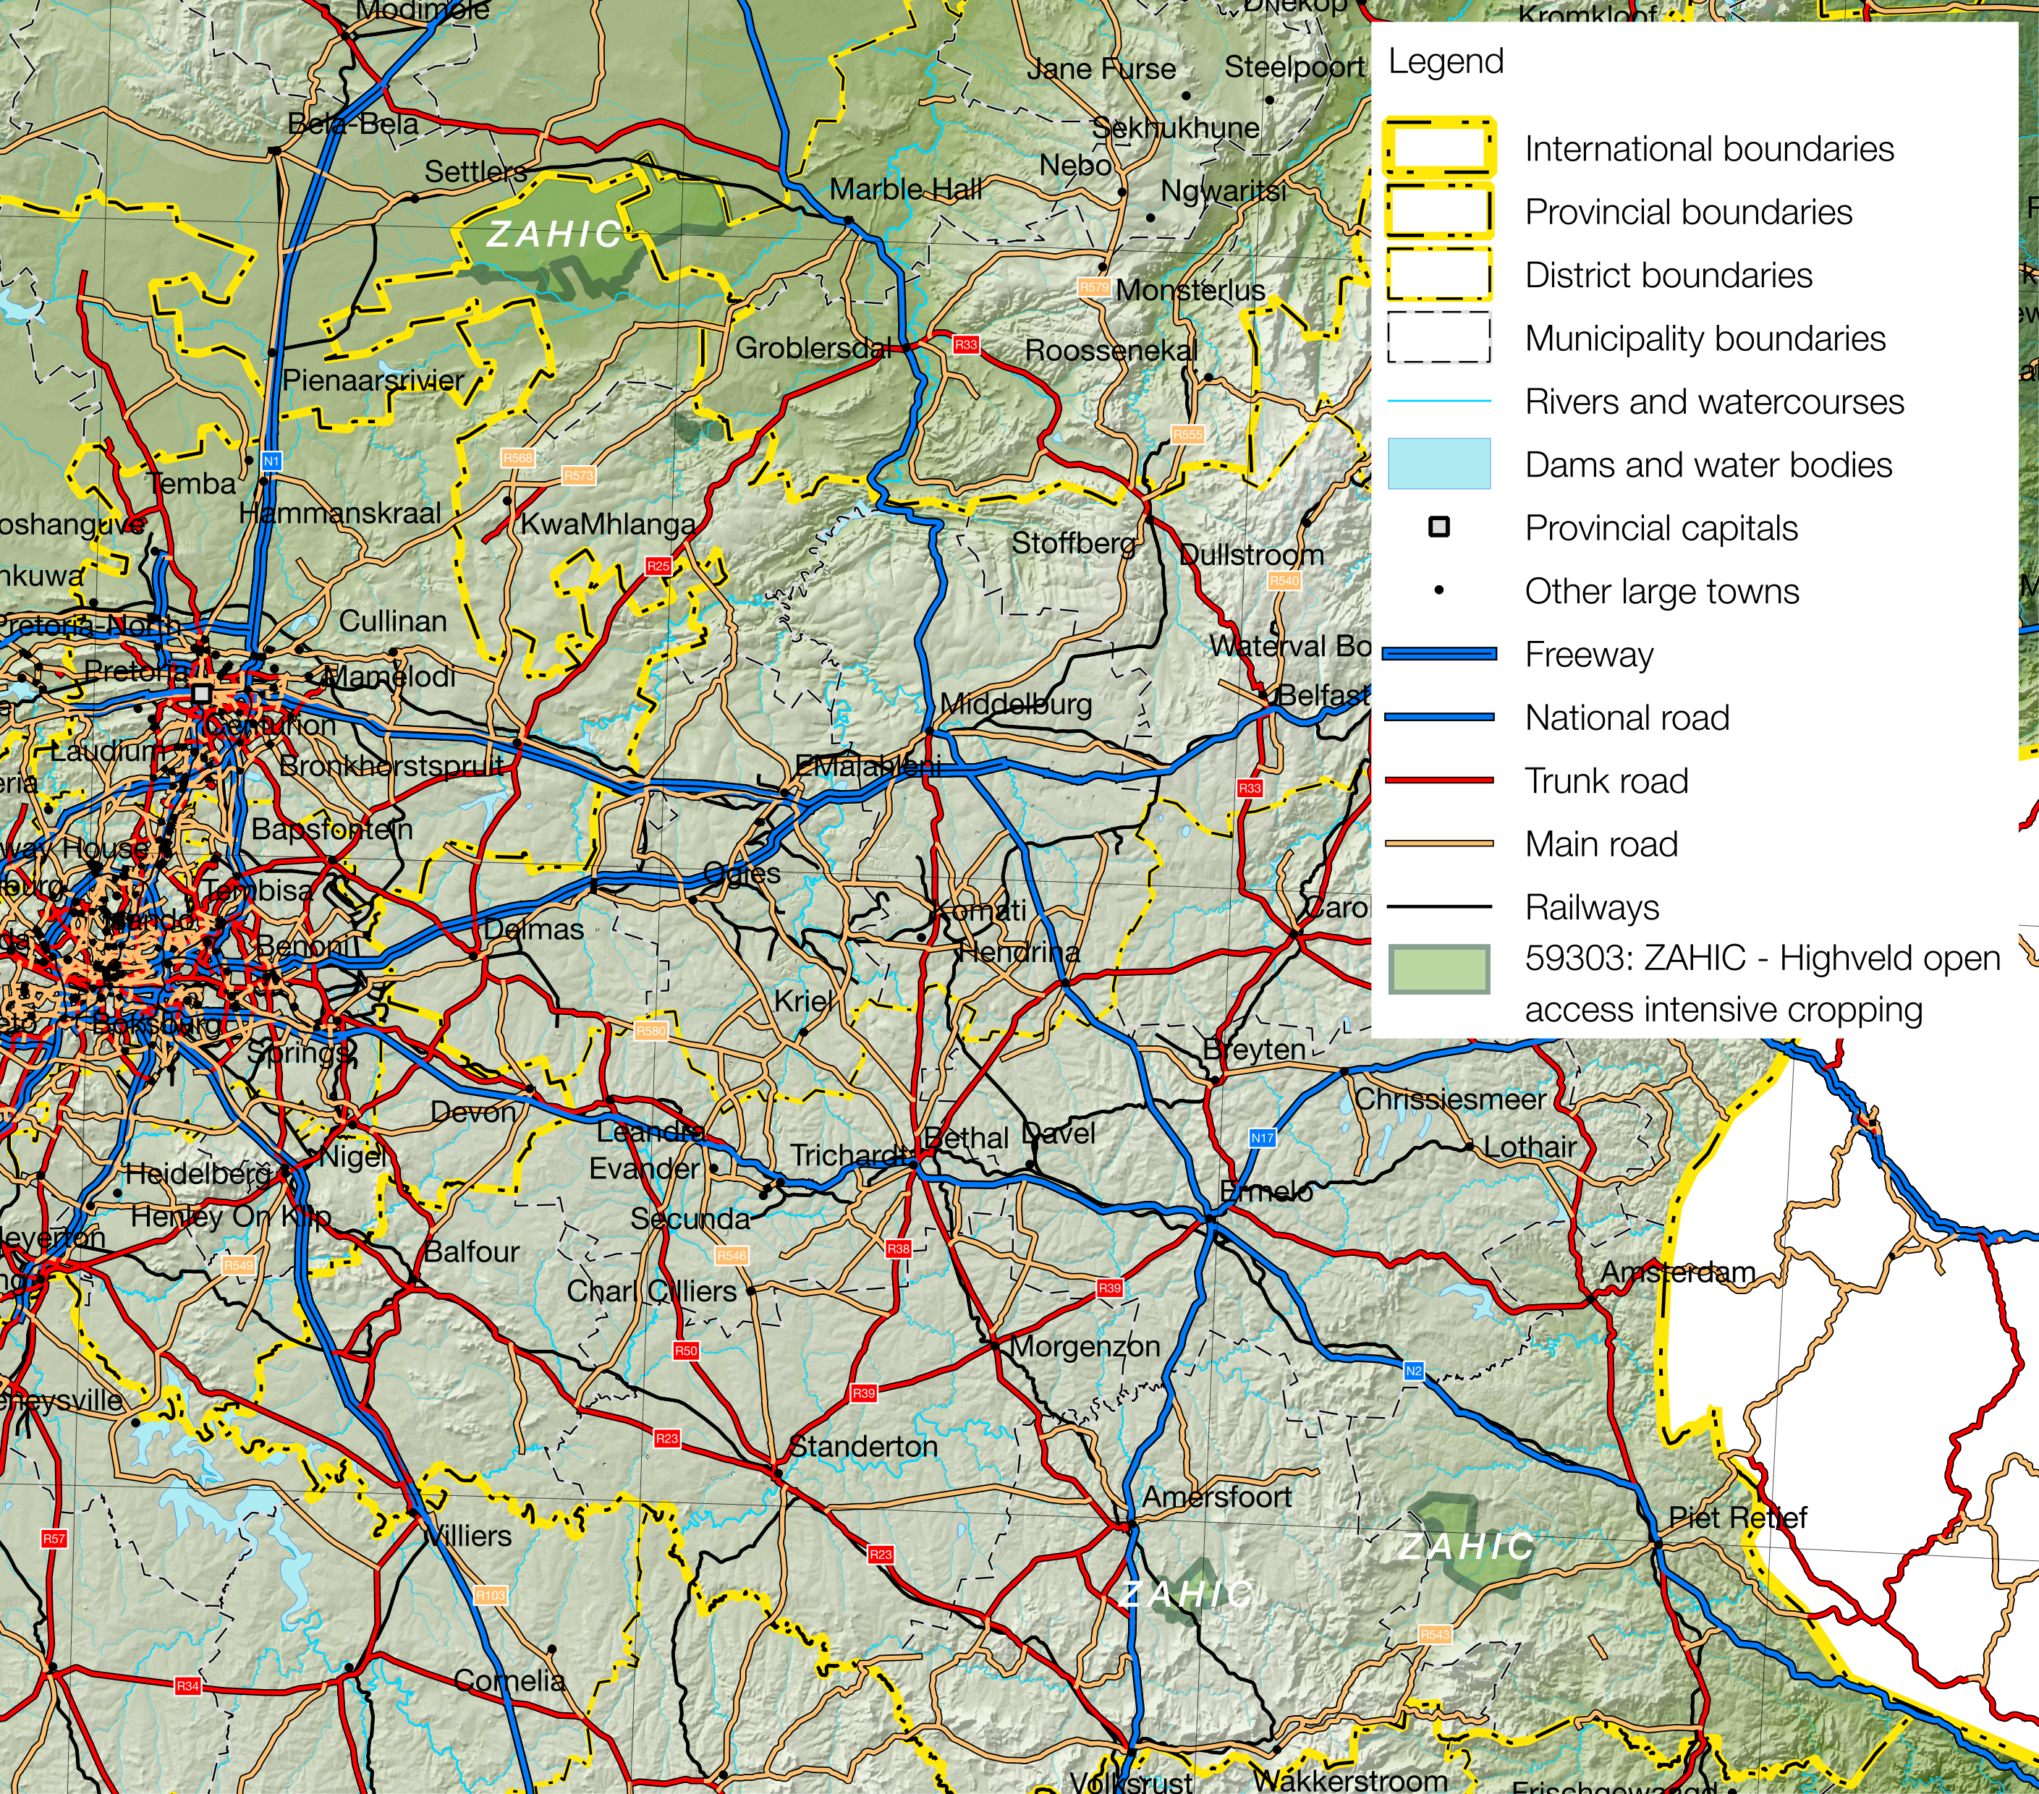

Projection: Albers Equal Area with Standard Parallels at 24.2 ªS and 32.8 ªS, Longitude of Centre at 25.1 ªE..

Sources of data: Open Street Map, Highways (<http://wiki.openstreetmap.org/wiki/Planet.osm>) for the road lines, Shuttle Radar Topography Mission (SRTM) 3 version 2.1 (<http://www2.jpl.nasa.gov/srtm/>) for the elevation and relief shading and Agricultural Geo-referenced Information System (AGIS) (<http://www.agis.agric.za/agisweb/agis.html>) for place names, boundaries and rivers.

* In the north, the largest section is a stretch of flat land straddling Mpumalanga (Dr JS Moroka and Thembisile Municipalities of Nkangala District) and Limpopo (Ephraim Mogale Municipality in Greater Sekhukhune District) to the west of Marble Hall;
* In the south, a section in Mkhondo Municipality, Gert Sibande District, around Saul Mkhizeville in Mpumalanga west of Piet Retief town; and
* A small area south of Amersfoort around Vlakpoort in Pixley ka Seme Municipality in Gert Sibande District.

The northern section of the zone receives 300 to 600 mm mean annual rainfall, while the two areas in the south receive 300 to 700 mm, while temperatures vary from 7º C to 35º C in the north and –2º C to 33º C in the southern sections. The rainfall is highly variable and the high summer temperatures wither crops from transpiration. Wealthier households keep a few cattle and goats. Households also depend on casual labour, remittances and grants.

Table 1 - 2016 Population breakdown of districts and municipalities covered by the livelihood zone, based on the 2011 Census and annual projections

|  |  |  |  |  |
| --- | --- | --- | --- | --- |
| **Province** | **District** | **Municipality** | **Pop. Est. in ZAHIC** | **% of Admin Level** |
| Limpopo | Greater Sekhukhune | Ephraim Mogale | 32,093 | 23.75% |
| **Provincial Total** | | | **32,093** | **0.55%** |
| Mpumalanga | Gert Sibande | Mkhondo | 30,065 | 15.96% |
| Pixley ka Seme | 16,965 | 18.62% |
| Nkangala | Dr J.S. Moroka | 50,370 | 18.14% |
| Thembisile | 16,437 | 4.76% |
| **Provincial Total** | | | **113,837** | **2.61%** |

Source: Statistics South Africa, Census 2011 small area population data and district population projections

Figure 2: Livelihood zone location

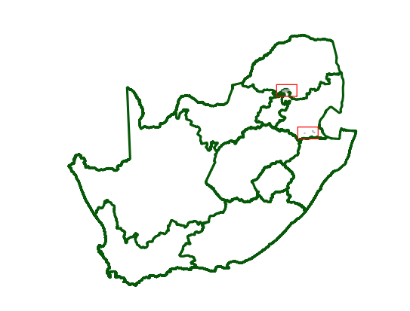

**Figure 1** is a map of the zone and **Figure 2** shows the location. The Nkangala/Sekhukhune section is served by feeder roads from the R33 between Marble Hall and Modimolle, as well as other feeder roads from the R568 through Siyabuswa and Madubaduba. There is also a railway line that skirts around the northern flank of the section from Marble Hall to Settlers. The Mkhondo section is served by the R543 from Piet Retief to Wakkerstroom or Volksrust. The Pixley ka Seme Section lies close to the N11 between Volksrust and Amersfoort or Ermelo. The Bethel to Volksrust railway also passes through Vlakpoort.

Figure 3: Gender and age breakdown of the zone population

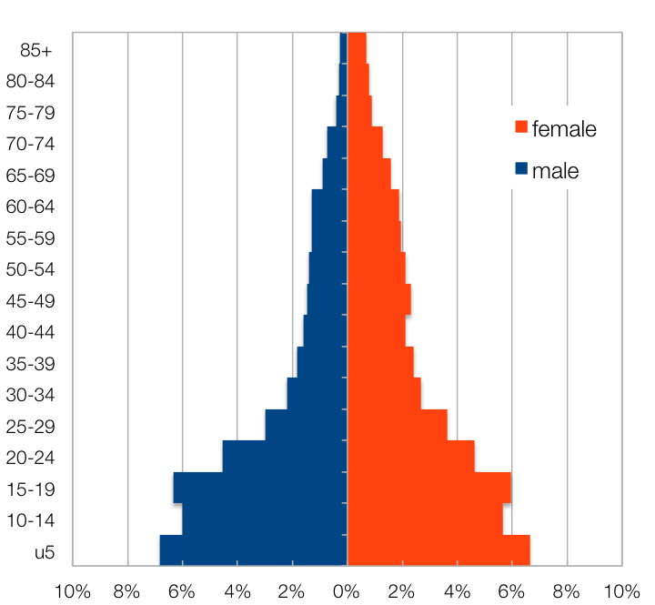

Source: Statistics South Africa, Census 2011 small areas and population database

The livelihood zone has been given an alphabetic code (or abbreviation) of ‘ZAHIC’ and a numeric code of 59303. These codes distinguish the zone both nationally and internationally while permitting name changes if desired (the code should remain the same).

The zone spans six municipalities in three districts across two provinces. However, only a small portion of the populations in each of these six municipalities are included in the zone. The total population in the zone is 145,930 (projected to 2016 from the Census 2011) and the Limpopo portion is 0.55% of the provincial total, while that of Mpumalanga is 2.61%.  **Table 1** shows the breakdown for each municipality.

**Figure 3** shows the age and gender breakdown of the livelihood zone. The lower proportion of adult men in the livelihood zone as well as the high proportion of children (younger than 20), an unbalanced gender and dependency ratio, is a consequence of apartheid, that forced men to seek work in the surrounding commercial farms and the urban, industrial and mining areas. The persistence of this pattern has impacts on productivity through to shortages of human capital and reduced labour availability.

Figure 4: Seasonal calendar

|  |  |  |  |  |  |  |  |  |  |  |  |  |  |
| --- | --- | --- | --- | --- | --- | --- | --- | --- | --- | --- | --- | --- | --- |
| Activity | Who? | Apr | May | Jun | Jul | Aug | Sep | Oct | Nov | Dec | Jan | Feb | Mar |
| Maize (Land Preparation) | Both |  |  |  |  |  |  |  |  |  |  |  |  |
| (Planting) | Both |  |  |  |  |  |  |  |  |  |  |  |  |
| (Weeding) | Both |  |  |  |  |  |  |  |  |  |  |  |  |
| (Green Consumption) | Female |  |  |  |  |  |  |  |  |  |  |  |  |
| (Dry Harvest) | Both |  |  |  |  |  |  |  |  |  |  |  |  |
| Sunflower (Land Preparation) | Male |  |  |  |  |  |  |  |  |  |  |  |  |
| (Planting) |  |  |  |  |  |  |  |  |  |  |  |  |  |
| (Weeding) | Both |  |  |  |  |  |  |  |  |  |  |  |  |
| (Dry Harvest) | Male |  |  |  |  |  |  |  |  |  |  |  |  |
| Beans (Land Preparation) | Both |  |  |  |  |  |  |  |  |  |  |  |  |
| (Planting) | Both |  |  |  |  |  |  |  |  |  |  |  |  |
| (Weeding) | Both |  |  |  |  |  |  |  |  |  |  |  |  |
| (Dry Harvest) | Both |  |  |  |  |  |  |  |  |  |  |  |  |
| Vegetables | Female |  |  |  |  |  |  |  |  |  |  |  |  |
| Casual Labour (Crop Fields) | Both |  |  |  |  |  |  |  |  |  |  |  |  |
| (Domestic Work) | Female |  |  |  |  |  |  |  |  |  |  |  |  |
| (Herding) | Male |  |  |  |  |  |  |  |  |  |  |  |  |
| (Public Work) | Both |  |  |  |  |  |  |  |  |  |  |  |  |
| Off-Farm Employment | Both |  |  |  |  |  |  |  |  |  |  |  |  |
| Livestock (Heat and Birth) |  |  |  |  |  |  |  |  |  |  |  |  |  |
| Livestock Sales | Male |  |  |  |  |  |  |  |  |  |  |  |  |
| Purchases (Low Prices) |  |  |  |  |  |  |  |  |  |  |  |  |  |
| (High Prices) |  |  |  |  |  |  |  |  |  |  |  |  |  |
| Labour Migration | Both |  |  |  |  |  |  |  |  |  |  |  |  |
| Annual Hunger |  |  |  |  |  |  |  |  |  |  |  |  |  |
| Health (Influenza) | Both |  |  |  |  |  |  |  |  |  |  |  |  |
| (Diarrhoea) | Both |  |  |  |  |  |  |  |  |  |  |  |  |

|  |
| --- |
| Seasonal Calendar |

Since this is a rural livelihood zone and rural life is determined by agricultural seasons, the information is organised by *consumption year*, which begins with the start of the main dry harvest and runs through to just before the next year’s main dry harvest. In this zone, the main dry harvest begins in April, so the consumption year begins that month and runs up until the end of the following March. The livelihood strategies presented in this document also apply to a particular year, one that is neither very good nor bad but occurs most frequently, that is, it is ‘typical’. This is called the *reference year* and the year chosen by participants was 2013-2014, or April 2013 to March 2014.

The main season for farming begins with land preparation in late winter (August), followed by ploughing and planting in spring, depending on the timing of the rains. Weeding (a period of intense activity and one in which work opportunities increase) takes place from December to April, with the dry harvest (another period for employment) beginning in April. The main crops grown during this period are maize, sunflower and beans.

Households strategise keeping up activities all year round, so that income flow can be as smooth as possible. Vegetables are grown off-season during autumn and winter (March to September), while the preferred time for selling livestock is at the beginning and end of the farming season. Casual work is done all year round, with farm work during the main season and public works during the second half of the calendar year (July to December).

|  |
| --- |
| Wealth Breakdown |

Wealth in this livelihood zone is determined primarily by three factors:

1. Employment, a product education and good social connections;
2. Land holdings; and
3. 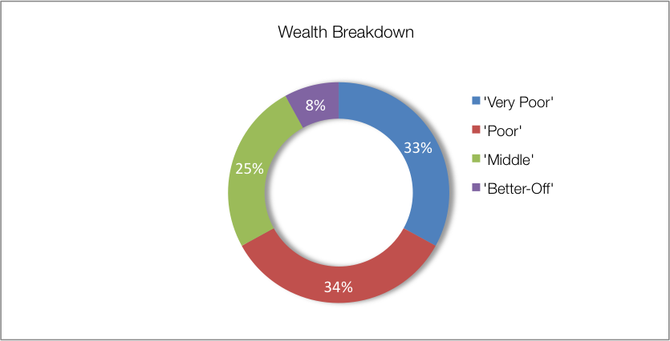Livestock, especially cattle.

The wealthiest households, described as the ‘better-off’, are those with permanent work and a salary of around R10,500 per month. Households that have lower-paying or less permanent work, which averages to approximately R3,500 per month, are referred to as the ‘middle’. Those who depend primarily on grants are described as ‘poor’ and ‘very poor’; collectively, they are about 67% of households. The ‘very poor’ and ‘poor’ supplement their grant income from casual labour and other sources.

Figure 5: Wealth breakdown in the lowveld open access irrigated cropping livelihood zone

|  |  |  |  |  |  |
| --- | --- | --- | --- | --- | --- |
| Category | Item | Wealth Group (typical value in brackets) | | | |
| 'Very poor' | 'Poor' | 'Middle' | 'Better off' |
| Hh Size |  | 5-10 (8) | 5-9 (7) | 4-9 (7) | 4-7 (6) |
| Land (Ha) | Owned | 0.05-1 (¾) | ¼-2 (1) | 1-2 (1.2) | 1-3 (2) |
| Cultivated | 0-1 (¼) | ½-2 (1) | ½-2 (1) | 1-3 (2) |
| Livestock (head) | Cattle | 0 | 0-4 (2) | 0-15 (10) | 5-60 (30) |
| Goats | 0 | 0-5 (3) | 5-13 (6) | 6-20 (10) |
| Income | Main | Grants | Grants | Formal employ | Formal employ / agric |
| Annual (R) | 37,700 | 70,500 | 96,600 | 348,200 |

Source: Survey output, 2016

Since farming in this zone is important and this requires resources and capital, the amounts of land owned and cultivated vary with wealth. ‘Better off’ households lever their fixed incomes and assets to develop more land and cultivate farms that are eight times larger than those of ‘very poor’ households.

During interviews key informants in the villages tended to use larger household sizes compared with those from other surveys such as the census. This was possibly due to key informants referring to family units rather than the stricter definition of household. These family units will certainly share some resources, including grants such as pensions and child grants, cultivated land (shared in terms of labour required and production) or the proceeds from casual labour. They are therefore used in the ensuing calculations on sources of food and income—these can be scaled to the appropriate household size from the census.

|  |
| --- |
| Sources of Food |

Sources of food are expressed in terms of contribution to the minimum human food energy needs, which is 8,800 kJ/person/day. Wealthier households may consume considerably more than this, for example 12,144 kJ/person/day, which is 138% of minimum food needs. Some of this consumption may be wasted, for example when food is thrown away or incompletely eaten. Even the poorest households may consume slightly more than the minimum requirement, for example 111%, or 9,768 kJ/person/day. **Figure 6** shows the contributions to food energy for each of the main food sources. Bear in mind that the bars *do not* represent quartiles; the numbers of people and households in each wealth group vary considerably.

Figure 6: Sources of food (expressed as percentage of minimum average food energy needs) for each wealth group

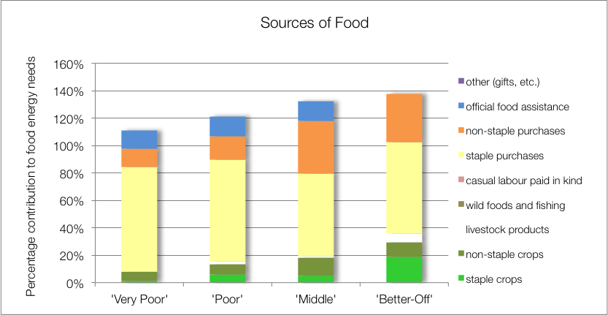

Purchases make up the largest portion of people’s sources of food. Food purchases contribute 90% to 102% of food energy needs; this is in with most other livelihood zones. The contribution to food energy from staple food purchase *decreases* steadily from 76% for the ‘very poor’ to 67% for the ‘better-off’. Conversely, the contribution to food energy from non-staple food purchases *increases* from 14% of energy requirements for the ‘very poor’ to around 38% and 35% for the ‘middle’ and ‘better off’, respectively. This is because non-staple foods are essentially more expensive kilojoules, which wealthier households can afford.

Households and all wealth groups also consume food from their own crop production; the contribution from staples rises significantly from only 1% for the ‘very poor’, to 19% for the ‘better-off’. Own produced non-staples—primarily green maize, beans, water melon and pumpkin—contribute a steadily rising amount of household food energy requirements with wealth, from 7% to 10%. However, the greater portion of this non-staple for the ‘very poor’ households is green maize, which reduces the production of their dry harvest and their food diversity.

Very little food is obtained from livestock; occasional slaughter for meat and a few households consume cow’s milk. Dairy production in this zone is not commensurate with herd sizes and livestock ownership and, in general, only a small fraction of lactating cows (about one out of every five) are actually milked for consumption.

The poorest households’ children receive additional food from school lunches, which is included as ‘official food assistance’. ‘Better-off’ households send their children to fee-paying schools that do not offer any kind of meals.

|  |
| --- |
| Sources of Cash Income |

Cash incomes vary considerably across wealth groups, with the ‘better-off’ earning R217,995 per annum, over four times as much as the ‘very poor’ who earn R45,760 per annum. **Figure 7** shows this distribution—it must be noted that the bars in the figure are not quartiles, they represent wealth groups and wealth groups are *not* distributed evenly (see **Wealth Breakdown**, above).

The main sources of cash income for in the zone are: formal employment and crop sales—for the ‘middle’ and ‘better-off’—and cash grants—for the ‘poor’ and ‘very poor’. This is in keeping with surveys that ask for the main cash source.

However, the point of this enquiry was to also gain understanding of how *all* income sources *add up* to make the sources of cash. This is essential because it enables practitioners to link a hazard (such as a price change) to outcomes and it enables other users to see potential areas of intervention. By dividing the value of each source by the total income, we can see these proportions and this is presented in the graph in **Figure 8**.

Grants, mostly old age and child, play a key role for the ‘very poor’ and ‘poor’. They make up 81% and 68% of total cash income, respectively. The remainder of their income comes from casual labour, mostly agricultural piece work, and domestic work. For the ‘poor’, small amounts of income are earned from crop and livestock (goat) sales.

Figure 7: Sources of annual cash income by wealth group

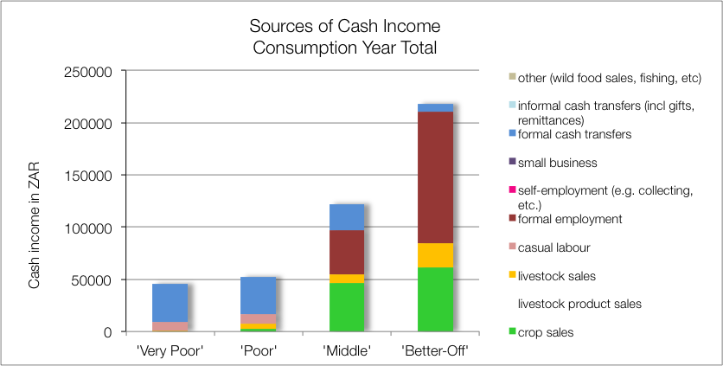

Figure 8: Sources of annual cash income as a percentage of total, by wealth group

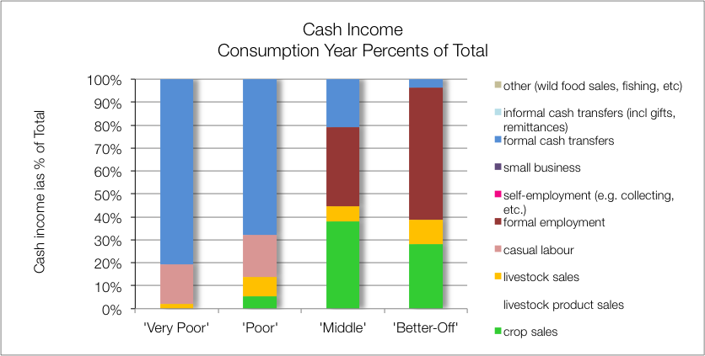

The relatively high incomes for the ‘very poor’ and ‘poor’ households in this livelihood zone are a consequence of the large household sizes given for these two wealth groups (nine and eight people, respectively). This larger household (or family unit) size increases the odds that the household receives grants, boosting their income. On a *per person basis*, the ‘better-off’ earn more than eight times as much as the ‘very poor’.

The ‘better-off’ gain wealth from a formal wage or salary for the better part of their income (R10,500 per month or 58% of their total). The ‘middle’ also have access to formal wages, but this is less regular or lower-paying (average of R3,520 per month or 35% of their total). A key difference in this livelihood zone when compared with other non-commercial farming rural zones in the provinces, is that both ‘middle’ and ‘better-off’ households grow cash crops such as sunflower and cotton, earning R46,620 or 38% of total and R61,700 or 28% of total, respectively, from this source. They also earn 6% and 10% of their total incomes, respectively. ‘Middle’ and ‘better-off’ households also benefit from grants (for example, the old age and fostering grants are not means-tested and the probability of a household having a pensioner in it is about one in two—see the population pyramid under **Zone Description**).

The numbers of cows that are actually milked compared with those likely to be lactating, is low. This is due to a number of factors: lack of economic incentives for milking, lack of time by the cattle-owners (because they are full-time employed) and minimal herd management.

|  |
| --- |
| Expenditure |

Absolute expenditures are shown in **Figure 9** and this varies across wealth groups in line with incomes. As with income, it is usually more instructive to obtain proportions of total expenditure and this is done by dividing the expenditure item by the total income. The results are graphed in **Figure 10**.

Figure 9: Annual cash expenditure, by wealth group

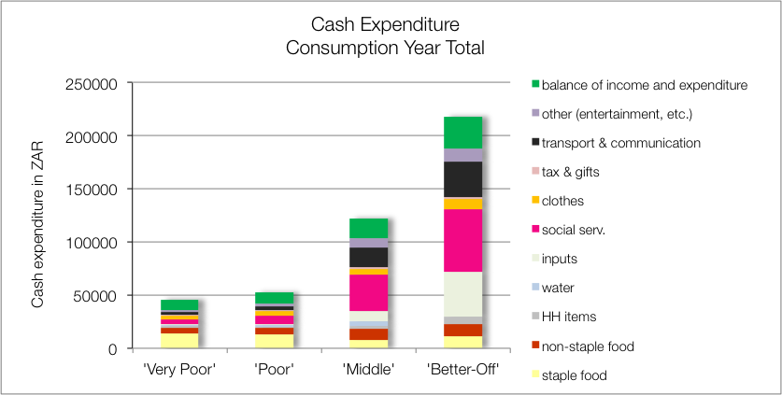

Social services such as health, schooling and taxes occupy a large proportion of expenditure for the ‘middle’ and ‘better-off’ (28% and 27%, respectively). These two groups also spend a greater proportion (15%) of their income on transport, which is needed for their produce to get to market. The ‘better-off’ spend a high proportion of their income on agricultural inputs: 19%. This consists of seeds (2%), fertiliser (1%), pesticides (1%), labour (13%), tools (1% and animal drugs (1%). Their expenditure on labour provides vital work for the ‘poor’ and ‘very poor’. A relatively small proportion of their incomes is spent on food: 15% for the ‘middle’ and 11% for the ‘better-off’.

Figure 10: Annual cash expenditure as a percentage of total income, by wealth group

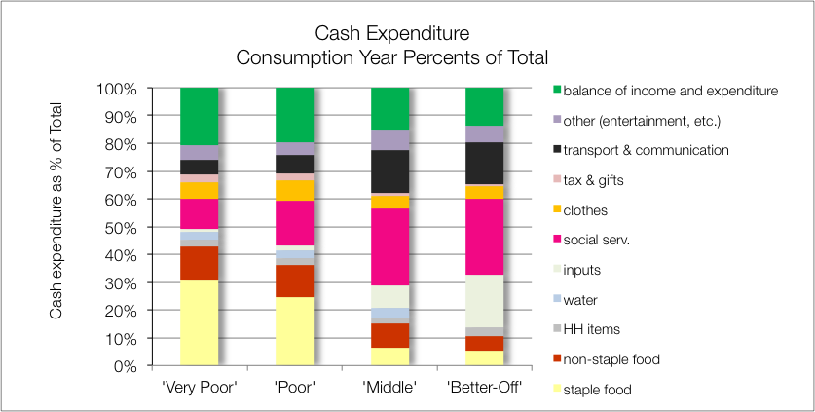

The ‘very poor’ and ‘poor’ spend most of their money on food: 43% and 36%, respectively. The amount they spend on staples is also a relatively large proportion: 31% and 24%, respectively.

|  |
| --- |
| Hazards, Vulnerabilities and Response Strategies |

Since ‘very poor’ and ‘poor’ households are dependent on markets for most of their food, they are most vulnerable to market-related shocks. These ‘market shocks’ may consist of: escalating food prices, eroded grants (for example, when they are not adjusted to match consumer inflation) and job losses.

Drought has a direct impact for the ‘middle’ and ‘better-off’, since it reduces their crop production and affects both their of food and their income. Because of their relatively high incomes, they are able to manage the food losses by increasing their purchases but if food prices rise simultaneously with the drought production shock, the middle will have difficulty coping. *Indirectly*, the ‘very poor’ and ‘poor’ will suffer income loss during a drought because the wealthier households reduce their demand for labour.

Additional response strategies households may engage in under stress are: switching expenditure, seeking more casual work (usually outside of the village) or selling off assets or belongings.

|  |
| --- |
| Household Hunger Score |

The majority (43 per cent) of the households in this Livelihood Zone were moderately food insecure. This was followed by 41 per cent of the households who were found to be mildly food insecure. Only six per cent of the households were found to be in a severe state of food insecurity. About 17 per cent of the households were food secure in this livelihood zone.

Figure 13: Consumption Scale in the Mpumalanga section of the zone

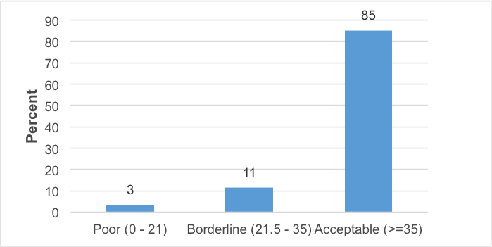

Figure 12: Household hunger scale in the Mpumalanga Province section of the zone

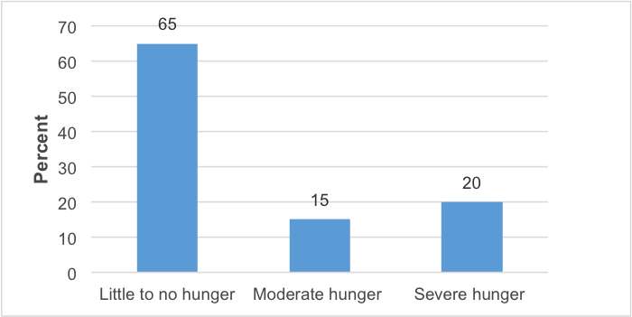

Figure 11: Household food security access scale for the Mpumalanga section of the zone

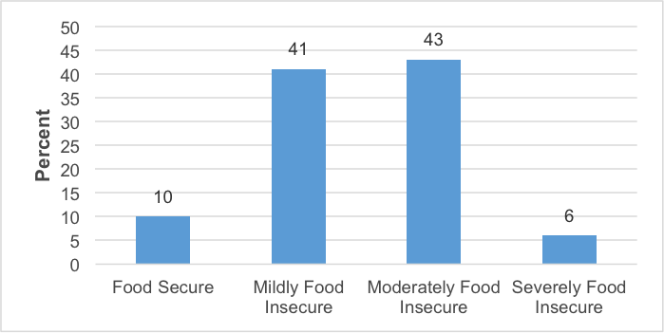

|  |
| --- |
| Dietary Diversity and Food Consumption Score |

The majority of the households (65 percent) experience no to little hunger and 20 per cent of households had severe hunger in this livelihood zone. Only 15 per cent of the households reported a moderate hunger situation – see **Figure 12**. This livelihood zone has a higher number of households experiencing hunger.

The majority of households – 85 per cent – were consuming acceptable diets. While 11 per cent of the households were within borderline consumption pattern, three per cent of the households were consuming poor diets.

|  |
| --- |
| Nutrition and Anthropometry |

No under-five children were found to be having severely acutely malnourished in this livelihood zone. Only under-five children of the age groupings 6-17 and 18-29 months old were found to be moderately acutely malnourished. No under-five children were moderately acutely malnourished in age groupings of 18-29, 42-53 and 54-59 months old.

Figure 14: Prevalence of severe and moderate acute malnutrition in the Mpumalanga section of the zone

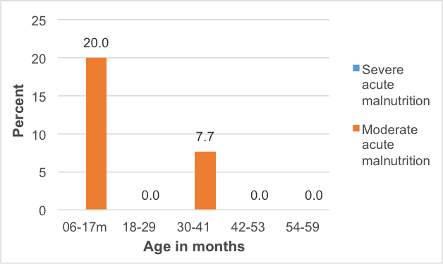

There is a high prevalence of moderate stunting among under-five children within 42-53 months old. Only the under-five children within the ages of 6-17 months and 42-53 months old did not have severe stunting. About 25 per cent and 13 per cent of the under-five children in the ages 18-29 months old were severely and moderate stunted in the this livelihood zone. No under-five children were found to be moderately underweight and severely underweight in this livelihood zone.

Figure 15: Prevalence of stunting in the Mpumalanga section of the zone

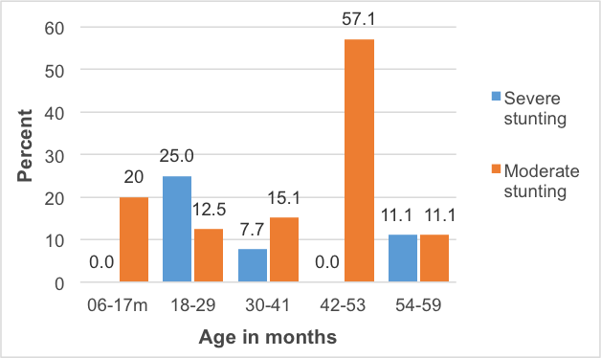

|  |
| --- |
| Conclusions and Recommendations |

Crop production is plays a significant role for some households in the zone, especially as a source of income. The zone has mixed income sources and the key will be to improve the access to services so that agricultural potential can be realised, providing more the people with greater diversified means of income. Agriculture has a good potential in zone as it is flat with good soils and there dams which can provide stable source of water if the irrigation schemes are put in place.

Food and cash incomes from livestock products are low for the numbers of animals present. To increase production, herds would need more and better management, an investment that would need to be justified through better returns. These returns could be increased by, for example, support to dairy marketing and greater provision of services and infrastructure to encourage production.

This increased productivity will unlikely benefit all but a few households directly, but will create additional new possibilities through increased work opportunities. For many 'poor' and 'very poor' households, grants will remain the main source of income for some time to come.

Figure 16: Detailed map of the Greater Sekhukhune district (Limpopo) and Nkangala district (Mpumalanga) section of the livelihood zone showing the sampled sites, other livelihood zones, administrative areas down to enumeration small areas, and infrastructure.

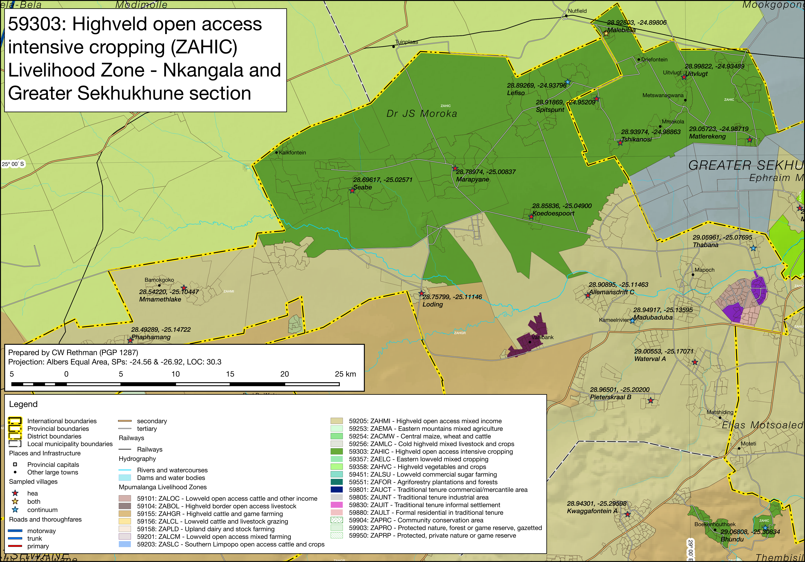

Figure 17: Detailed map of the Gert Sibande district (Mpumalanga) section of the livelihood zone showing the sampled sites, other livelihood zones, administrative areas down to enumeration small areas, and infrastructure.

